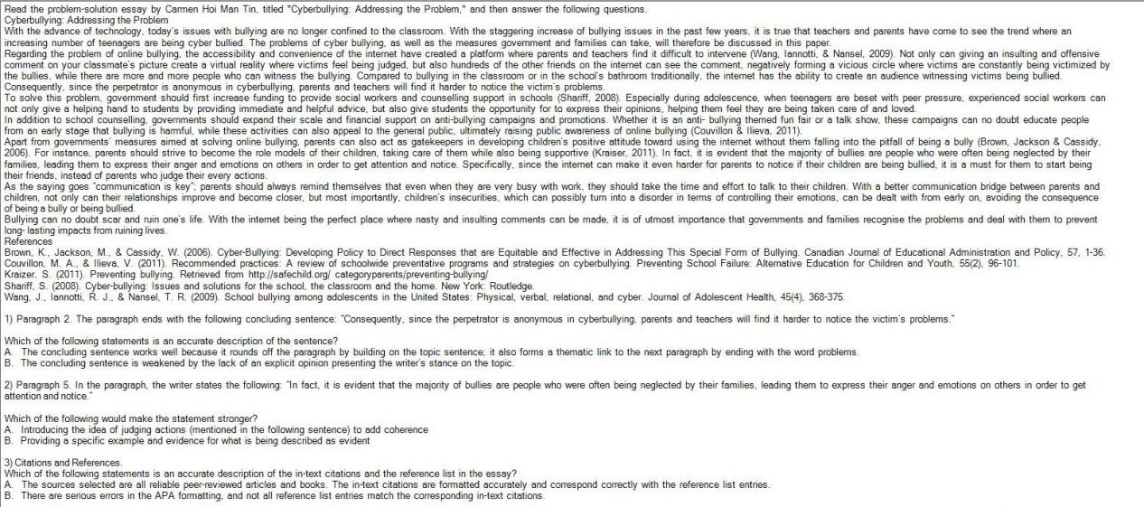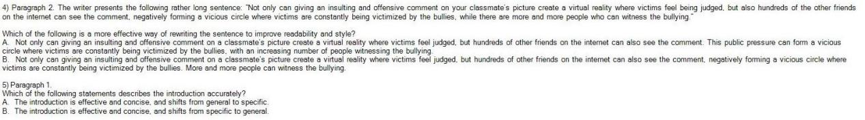

1. A. The concluding sentence works well because it rounds off the paragraph by building on the topic sentence; it also forms a thematic link to the next paragraph by ending with the word problems.
2. B. Providing a specific example and evidence for what is being described as evident
3. A. The sources selected are all reliable peer-reviewed articles and books. The in-text citations are formatted accurately and correspond correctly with the reference list entries.
4. A. Not only can giving an insulting and offensive comment on a classmate's picture create a virtual reality where victims feel judged, but hundreds of other friends on the internet can also see the comment. This public pressure can form a vicious circle where victims are constantly being victimized by the bullies, with an increasing number of people witnessing the bullying.
5. A. The introduction is effective and concise, and shifts from general to specific.